**Prerequisites - Setup the environment**

I used amazon ec2 ubuntu instance to do this project.

Install datadog agent

## Collecting Metrics:

Add tags in the datadog.yaml file

#env_test:datadog_tags_test

#test:succeeded

## And also added user tags

#my_sql_integration_datadog, #yukti

<https://app.datadoghq.com/infrastructure/map?host=2076341972&fillby=avg%3Acpuutilization&sizeby=avg%3Anometric&groupby=availability-zone&nameby=name&nometrichosts=false&tvMode=false&nogrouphosts=true&palette=hostmap_blues&paletteflip=true&node_type=host>

<https://app.datadoghq.com/dash/host/2076341972?from_ts=1583737644506&to_ts=1583741244506&live=true&tile_size=m>

INSTALL MYSQL on the ubuntu Host Machine

Create a datadog user in mysql

Verify that the user was created

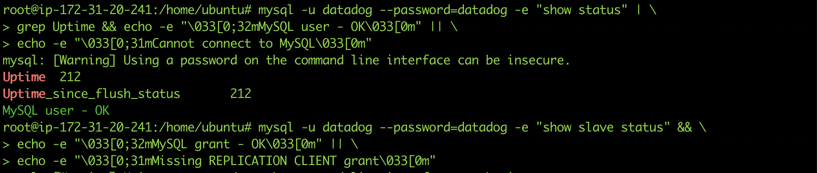

Mysql Integration with DataDog Agent

mysql.d/conf.yaml

Snapshot of /etc/mysql/my.cnf

MySql integration is successfully installed.

<https://app.datadoghq.com/dash/integration/12/mysql---overview?from_ts=1583736733706&to_ts=1583740333706&live=true&tile_size=m>

Create a custom Agent check that submits a metric named my_metric with a random value between 0 and 1000.

**cat /etc/datadog-agent/checks.d/my_metric.py**

from datadog_checks.checks import AgentCheck

from random import randint

class Check(AgentCheck):

def check(self, instance):

self.gauge('my_metric', randint(0,1000))

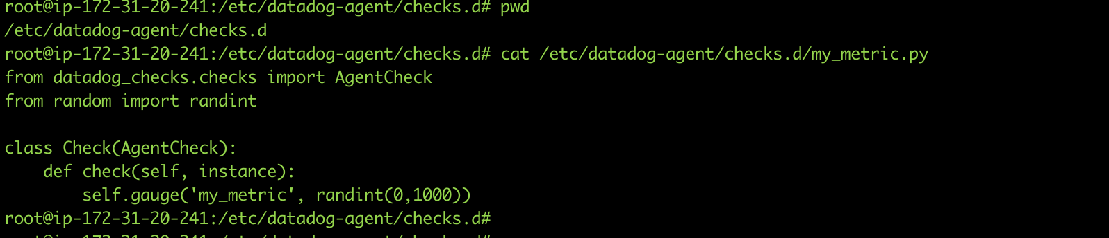

**cat /etc/datadog-agent/conf.d/my_metric.yaml**

init_config:

instances:

- min_collection_interval: 30

Change your check's collection interval so that it only submits the metric once every 45 seconds.

**cat /etc/datadog-agent/conf.d/my_metric.yaml**

init_config:

instances:

- min_collection_interval: 45

**Bonus** Question Can you change the collection interval without modifying the Python check file you created?

Yes, just change the parameter min_collection_interval to the desired value in the my_metric.yaml file.

<https://app.datadoghq.com/metric/explorer?live=true&page=0&is_auto=false&from_ts=1583737571929&to_ts=1583741171929&tile_size=m&exp_metric=my_metric&exp_agg=avg&exp_row_type=metric>

## Visualizing Data:

List of dashboards

<https://app.datadoghq.com/dashboard/lists>

<https://app.datadoghq.com/dashboard/d2r-ewr-arn/mymetric?from_ts=1583739229257&to_ts=1583740129257&live=true&tile_size=l>

Take a snapshot of this graph and use the @ notation to send it to yourself.

<https://app.datadoghq.com/event/stream?tags_execution=and&show_private=true&per_page=30&aggregate_up=true&use_date_happened=false&display_timeline=true&from_ts=1583737500000&priority=normal&is_zoomed=false&status=all&to_ts=1583741100000&is_auto=false&incident=true&only_discussed=false&no_user=false&page=0&live=true&bucket_size=60000>

It is displaying that the metric values go above or below the expected range based on past trends.

## Monitoring Data

@ahujayukti2@gmail.com

{{#is_alert}} Critical Alert: **my_metric** has a value of {{value}} and it is above {{threshold}} on Host IP: {{host.ip}} {{/is_alert}}

{{#is_warning}} **my_metric** is now warn over value of {{value}} on host {{host}} {{/is_warning}}

{{#is_no_data}} **my_metric** received no data for a period of 10m {{/is_no_data}}

{{#is_recovery}} Recovery Message: **my_metric** has recovered from an alert with a value of {{ok_threshold}} {{/is_recovery}}

Email notification screen shot

Bonus question (scheduled downtime monitor, I changed the time to 11pm as I wanted to take the screenshot when I was working on the test.)

Two Monitor recurring scheduled

## Collecting APM Data:

<https://docs.datadoghq.com/getting_started/tracing/>

APM and infrastructure metric dashboards

<https://app.datadoghq.com/dashboard/wb7-dgh-pgb/yuktis-timeboard-11-mar-2020-0147?from_ts=1583902663334&live=true&tile_size=m&to_ts=1583906263334&tv_mode=false>

## Final Question:

Datadog has been used in a lot of creative ways in the past. We’ve written some blog posts about using Datadog to monitor the NYC Subway System, Pokemon Go, and even office restroom availability!

Is there anything creative you would use Datadog for?

I would use datadog to analyze airport data. By capturing data from in and around the airport and analyzing it to get

1. most travelers through security lines in less time.
2. AND finding wifi spots for the travelers at the airport, so that the travelers have a smooth experience using wifi.
3. AND monitoring rest room traffic for the travelers, so that travelers know exactly where to go in those huge airports when they are traveling.